**Best place to open new Gold’s Gym**

Lucas Tiago de Oliveira

June 29, 2020

1. **Introduction**
   1. Background

The Gold's Gym is, maybe, the most famous chain gyms in the world, where many actors and famous people use to work out, for many persons say there is one temple of the worldwide bodybuilder. More especially, the unity which we want to study is located in Los Angeles (735 S Figueroa St Ste 100, Los Angeles, CA 90017, United States of America), where is very crowded because it has many users using the same place at the same time.

For spread and don't lose your clients, the owner had one idea: "I want to open a new gym around 500 meters the old gym!". But he knows in this neighborhood have a lot of competitors with other gyms, to decrease the change to lose clients the owner wants to know how he can open the new gym station in a location with fewer concurrent.

* 1. Problem description

There are a lot of other places in Los Angeles for service the gyms lovers, more specifically, in that neighborhood has many gyms struggling to expand their number of clients. Whether one stakeholder wants to improve his business-related gym in that neighborhood, he needs to know where is the best location for a new gym, or in other words, where is the localization has less concurrent in that neighborhood.

* 1. Interest

Obviously, gyms owners around the neighborhood, but in this case, we want to understand the Gold’s Gym problem, relative its expansion.

1. **Data acquisition and cleaning**
   1. Data sources

The data source we’ll use for solve this problem, it would acquire by using the Foursquare API developed for Python, because in that repository has a lot of information about the location of several types of location, including types of places and there are interesting data about gyms. But to acquire this amount of data, the API’s user needs to create one account on the Foursquare and get access to the Development Portal (Web site URL: https://developer.foursquare.com/).

For one free account, the user has a limited amount of calls that we can access, that account allows a limit of 950 Regular API Calls per day and 50 Premium API Calls. Regular API calls only return basic firmographic data, the venue category, and a venue ID. Premium API calls return rich content such as photos, tips, menus, URLs, ratings etc [1]. For more detailed information, please come to Foursquare website, where is the documentation about that API.

* 1. Data cleaning

As mentioned above, the data source used for analyze this problem is the Foursquare API, that is received through a .json file. But, Json file is not useful directly for data analyzes, for this is more suitable use the relevant data into that file and transform in different type.

The indicated and more useable to data manipulation for Python language is Pandas package, which provide fast, flexible, and expressive data structures designed to make working with structured (tabular, multidimensional, potentially heterogenous) and time series data both easy and intuitive [2]. That library treats its data using a dataframe, which contains labeled axes (rows and columns), to transform Json file in Dataframe, there is fuction *json_normalise.* For example, the output data of Foursquare API, has been shown below at Figure 1.



Figure 1 - Example of Json sends by Foursquare API.

Nevertheless, the useful part of this data or feature is provided by attribute “venues”, whose are generated by Foursquare output. After those data had transformed to dataframe type, it allows the work with the data, to acquire the data in Foursquare API, it’s necessary to put the latitude and longitude where it gets the data and in this case, the API output would get the data of the Gold’s Gym location, but for this analyses, in a certain moment, this data had dropped in the dataframe.

The resultant dataframe, which has a content with information of the gyms located around in radius 800 meters of the gold’s gym installation, has a shape with 49 rows and 15 columns. The image with all the 49 gyms, which has searched on the API call, is shown in Figure 2.

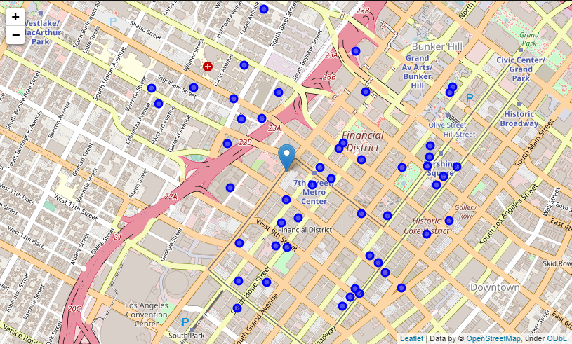

Figure 2 - Gyms around of Gold's Gym installation at 735 S Figueroa St Ste 100, Los Angeles.